**Introduction to Metaverse and its potential as a gaming platform**

**Metaverse – The virtual world**

The Metaverse is a concept for a 3D virtual world that develops the Internet into a more immersive and frictionless Web that can be accessed by common computing devices like the PCs and smartphones we all use in addition to Virtual Reality (VR) and Augmented Reality (AR) headsets. With a unique digital identity, you may explore its vibrant 3D virtual worlds. You can do a lot of things online, such work in a virtual office, play games, shop, hang out with pals, and much more. Additionally, you may link and incorporate immersive content. It is a location where you may interact socially with other users and virtual characters that are powered by artificial intelligence, creating events that are meant to be enjoyed by everybody.

The COVID-19 pandemic has also stimulated interest in designing and implementing metaverses for a variety of use cases and applications. There is now a larger need for more exciting and creative ways to communicate with friends and co-workers as more people have begun working remotely. Every day, more and more virtual 3D locations are developing that let workers connect, attend meetings, and catch up. The Microsoft Mesh platform, which was unveiled in November 2021, is a very good example. The immersive spaces that allow users to connect and collaborate with their digital avatars will make remote team meetings and conferences more engaging and entertaining.

Despite the fact that the global gaming industry is currently growing in every country, its current structure favors game producers over players and encourages a one-way value chain in which players must pay in order to access in-game materials and gameplay options. Thanks to blockchain-based games and decentralized apps, users may more effectively capture the value and utility of in-game purchases and asset acquisitions (dApps).

Blockchain technology in gaming is made feasible by non-fungible tokens (NFTs), which are digital assets that substitute for in-game content in the Metaverse. While these tokens are unique, unusual, and indivisible, the blockchain networks that allow NFTs give player ownership and have demonstrated scarcity, interoperability, and immutability. When combined, these advantages may promote wider adoption and a far more equitable value model.

**The definition of a play-to-earn NFT game**

A play-to-earn NFT game is a blockchain-based metaverse game that rewards players with NFTs, character skins, or cryptocurrencies. These may be acquired through completing levels, competing in events, or simply playing the game for a time. Players' resources can be used to increase their winnings or sold in a virtual market place. As the name implies, you also make more money the more you play.

The majority of play-to-earn games are decentralised, in contrast to most video games, which implies that players and developers jointly control them. By participating in the in-game economy, gamers provide value for both the developer and other players. Of course, developers also gain from lower transaction costs.

**Metaverse Gaming industry**

Gaming is a multi-billion dollar industry, and by 2025, it is expected that the video gaming market will be worth $268.81 billion.

With the introduction of the Metaverse in gaming, players may engage in virtual reality gaming. The inclusion of a metaverse in games has the potential to ignite a frenzy and boost the whole gaming industry.

**The Advantages of NFTs for Gaming**

Decentralized gaming offers a variety of advantages, including:

**Ownership:** Traditional in-game purchases are one-time, non-transferable expenditures trapped in a certain gaming universe.

**Scarcity:** The permanent records included in an NFT's underlying blockchain network make it possible to demonstrate the scarcity of in-game NFT purchases, which is important to collectors who value rarity and authenticity.

**Inter-function ability:** NFTs may be used to represent game assets that can function in a variety of contexts. For example, it is possible for two games created on the Ethereum network to share identical in-game assets like vehicles, armour, or even whole characters.

**Immutability:** NFTs are based on the blockchain itself and are not dependent on anyone's gaming platform. So, irrespective of what happens to the games, players can still buy and sell items in-game, and new games may be developed that work with an existing blockchain system.

**The expanding game business centred on Metaverse**

Console, PC, and mobile gaming are the three market divisions that make up the worldwide gaming market; together, their combined revenue is in the hundreds of billions of dollars and is continually growing. After investing a lot of money on expensive consoles, PCs, or mobile devices, players visit gaming environments that provide a tier-access user experience. Players must pay to access deluxe features and in-game material in these traditional games, thus money only flows in one direction.

Increasing player value is the main objective of blockchain-enabled games, many of which are decentralized apps (dApps). For instance, a player only receives improved gameplay for that particular game when they purchase an armor upgrade in a traditional game. However, the same armor may be tokenized in a way that transforms in-game purchases into transferable assets that grant benefits across connected games or can be exchanged for cash in a gaming setting that makes use of cross-platform non-fungible coinage, or other digital assets (NFTs).

These NFTs may be developed and used in a variety of gaming scenarios thanks to the underlying blockchain networks. Since NFTs are unique and may be designed to maintain value outside of the game in which they were originally formed, blockchain-based games can greatly expand gaming economies, introduce new gaming categories, and encourage the development of new games. Understanding NFTs is essential before looking at how this process may work.

**Conclusion:**

Although there are benefits to using NFTs in the gaming business, there are also significant problems that need to be fixed. Above all, NFTs need to be made more alluring and intelligible for regular customers who might not be technically savvy. Given that NFTs have intrinsic worth, there is a possibility that some of them will be used exclusively as speculative assets. This feature can tempt players to purchase in-game goods in order to sell them later on for a profit rather than making proper use of the environment's resources.

Despite these challenges, more companies that are not blockchain-focused may experiment with NFTs as the opportunity for financial benefit in the gaming industry encourages them to do so. They'll most likely achieve this by collaborating with other blockchain projects that have the requisite technical know-how to help them reach their objective. At the same time, it's likely that the broad acceptance of gaming-related dApps will encourage further development of the NFT infrastructure and the development of original solutions that enable mass adoption.

**Grammarly screenshot**

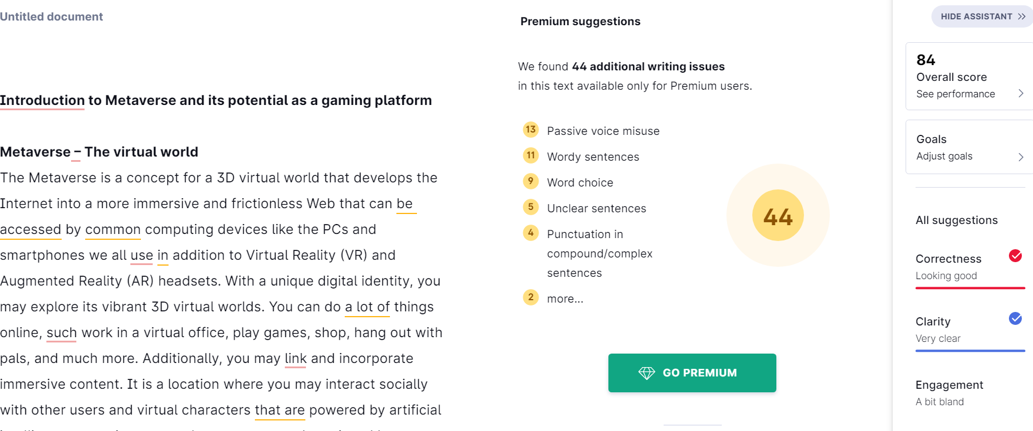

**Plagiarism checker screenshot:**

